# TVA

# Introduction

Theory of Visual Attention (TVA) explores how visual stimuli compete for limited attentional resources, and provides an approach to experimentally study and mathematically model relevant visual attention parameters (Habekost, 2015). TVA-based tests have proven to be very sensitive (Habekost, 2015).

TVA modelling provides estimates of five parameters. The t0 parameter is the threshold for perception (ms); *K* is the visual short-term memory capacity (number of letters); *C* is the processing speed (letters per second); $α$ represents ability to select between relevant and irrelevant stimuli; *w*-values indicate the attentional weight each stimulus position is given and are used to calculate the *w*index parameter which expresses distribution of attentional resources between left and right visual fields with 0.5 denoting equal distribution (Habekost, 2015; Vangkilde et al., 2011).

In this experiment, it is expected that longer display times will allow participants to correctly identify more letters. Likely, participants will not be able to perfectly select between stimuli; top-down selection processes will likely be disturbed by bottom-up processes (Radvansky & Ashcraft, 2014). Most TVA studies find a positive correlation between parameters *K* and *C*, and some studies have found age to correlate with all TVA parameters (Habekost, 2015). Thus, such correlations are expected to be found. Further, it is tested whether there appear to be any gender differences in performance.

# Methods

This experiment included *N* = 207 participants, 37 male and 169 female, all psychology students at UCPH.

## Materials

* CombiTVA task Eprime file

## Test procedure

The experiment was computer-based and conducted individually using an Eprime file. The present task was to report all target letters participants (P) were fairly certain they had seen from a stimuli set displayed on-screen. The experiment included whole report (WR), containing all target letters, and partial report (PR), containing some target and some distractor letters, trials. Targets and distractors were separated by colour (blue or red). Instructions were read on-screen.

The experiment consisted of nine blocks, each containing 27 trials in which a target coloured fixation cross was shown followed by a set of six letters shown for 16, 33, 50, 100, 150, or 200 ms. The letters were then masked, and P reported relevant target letters using corresponding keys on the keyboard.

There were four possible set conditions; all targets, or a mix of targets and distractors in ratios 2:4, 3:3, or 4:2. Accuracy was measured, and P was given feedback after each block and was instructed to aim for 80-90% accuracy. The test included a training session.

# Results

All statistical results were obtained using SPSS.

## Longer display times allow for more letters to be correctly identified

Figure 1 displays mean number of correctly identified letters across six targets displays and for displays with two targets and four distractors. Figure 1 provides initial indication that longer display times allow participants to report a greater number of correct letters than shorter display times do. Further, it appears that selection is present but imperfect in PR trials.

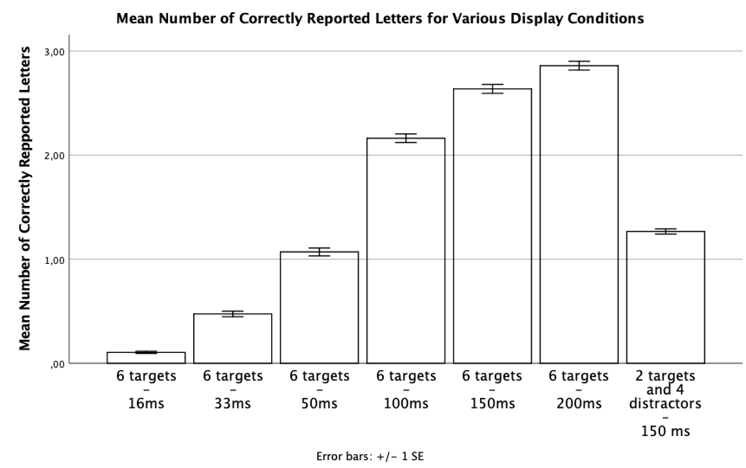

Figure 1: Mean number of correctly identified letters across relevant display conditions for entire sample.

A repeated measures ANOVA showed a significant main effect of display time on number of correctly identified letters in six target displays, *F*(2.00, 411.36) = 3018.09, *p* < .001, $η_{p}^{2}$ = .94 (Huyhn-Feldt corrected).

This statistically verifies that number of correctly identified letters varies between display times with longer display allowing enhanced correct identification (Figure 1).

Figure 2 displays a TVA plot for FP19202. This shows how FP19202 expresses a similar pattern, correctly identifying more letters with longer display times, and thus confirms that such effects are present at an individual level.

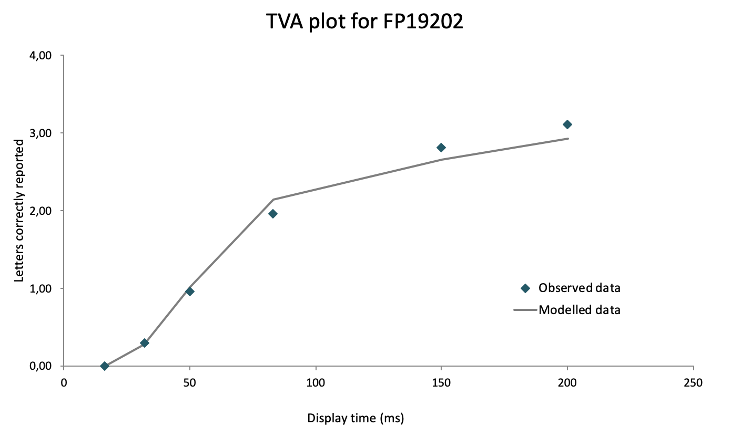

Figure 2: TVA plot over six targets display conditions for FP19202.

## TVA parameter correlations

Two-tailed Pearson’s correlations showed significant positive correlations between parameters *K* and *C*, *r*(205) = .47, *p* < .001, as expected, and between age and parameter $α$, *r*(205) = .18, *p* = .01. Age did not correlate with any of the other TVA parameters, *r*s ≤ .13, dfs = 205, *p*s ≥ .07.

Thus, participants with greater visual short-term memory capacity also had greater processing speed (Figure 3), implying some underlying similarities between parameters *K* and *C*. Further, older participants tended to have worse selectivity than younger ones. The lack of other age related correlations may be attributable to the distribution of age in our sample.

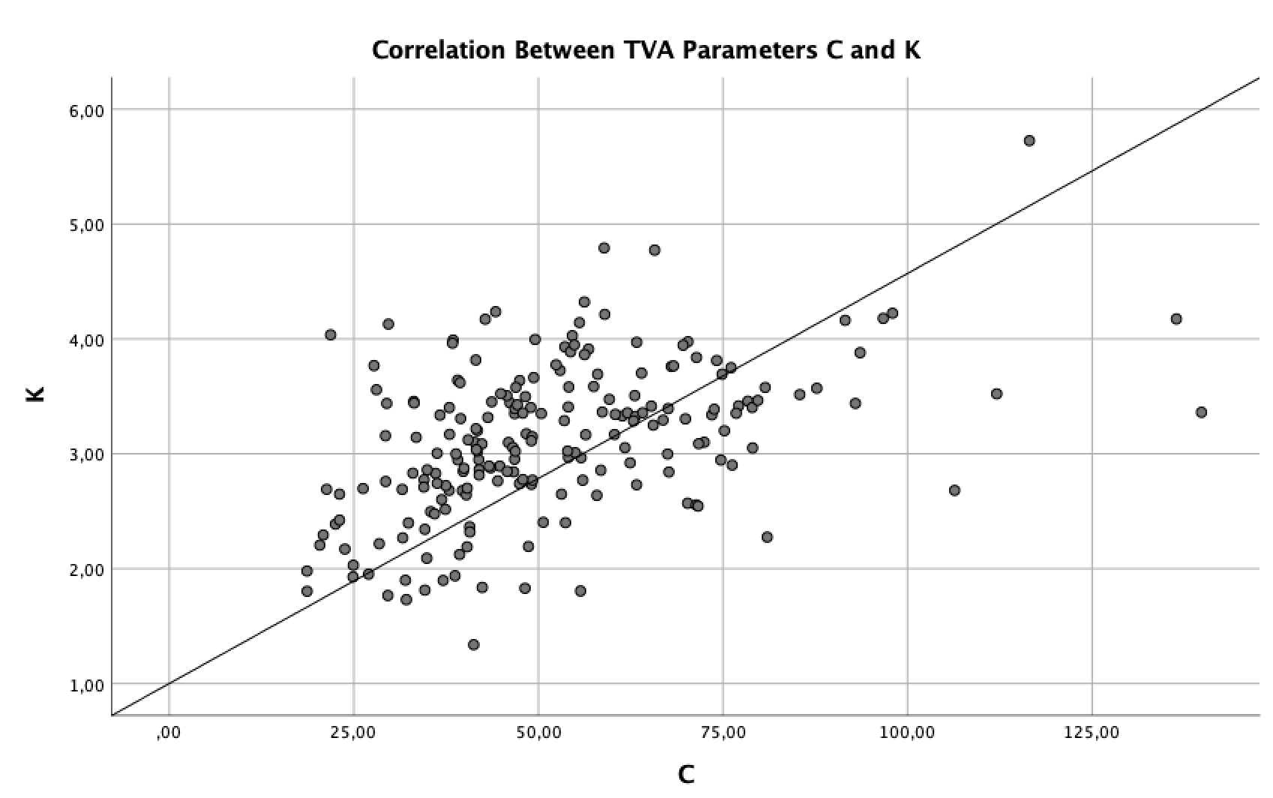

Figure 3: Scatterplot displaying significant positive correlation between parameters K and C.

## Female participants did not distribute there attentional resources equally

Independent-samples *t*-tests (two-tailed, $α$ = .05) were used to test for gender differences in all TVA parameters. Results are shown in Table 1.

|  |  |  |  |  |  |  |  |  |  |
| --- | --- | --- | --- | --- | --- | --- | --- | --- | --- |
| Table 1 *Mean* *TVA estimates and error rates distributed across gender with relevant t-tests.* | | | | | | | | | |
|  | Female (*N* = 169) | |  | Male (*N* = 37) | |  | *t*-tests | | |
|  | *M* | *SD* |  | *M* | *SD* |  | *t*(204) | *p* | *d* |
| *t*0 | 18.55 | (9.20) |  | 16.49 | (8.26) |  | 1.25 | .21 | 0.24 |
| *C* | 51.47 | (19.62) |  | 52.61 | (22.21) |  | -0.31 | .76 | -0.05 |
| *K* | 3.10 | (0.65) |  | 3.18 | (0.68) |  | -0.71 | .48 | -0.13 |
| $$α$$ | 0.40 | (0.31) |  | 0.35 | (0.36) |  | 0.89 | .38 | 0.15 |
| *windex* | 0.54 | (0.10) |  | 0.50 | (0.10) |  | 2.23 | .03 | 0.41 |
| *Error rate* | 0.15 | (0.07) |  | 0.16 | (0.07) |  | -0.51 | .61 | -0.09 |
| *Note*. Units: *t*0 (ms), *C* (letters/second), K (letters), *α* runs from perfect selectivity at 0.0 to no selectivity at 1.0, *w*index (< 0.5 = right side weighting, > 0.5 = left side weighting). | | | | | | | | | |

These showed a significant difference between *w*index for women versus for men (Table 1), but no significant differences between women and men for any of the other TVA parameters (Table 1).

This means that men and women perform similarly on the TVA task, obtaining similar estimates of all parameters except for *w*index. Men seem to distribute their attentional resources equally between the two visual fields, whereas women have a slight tendency to favour left visual field stimuli. However, the distribution of gender in this study was very skewed, providing a biased standard for comparison.

A one-sample *t*-test (two-tailed, $α$ = .05) showed that *w*index was significantly different from 0.5 for the entire sample, *t*(206) = 5.33, *p* < .001, *d* = 0.37. This means participants generally had a slight tendency to favour left visual field stimuli (*M* = 0.54, *SD* = 0.10).

## Imperfect selection

If selectivity was perfect then participants should be able to correctly identify the two target letters in the two targets and four distractors displays. However, Figure 1 implies this was not the case.

A one-sample *t*-test (two-tailed, $α$ = .05) showed a significant difference from 2 for mean number of correctly identified letters in these displays, *t*(206) = -29,47, *p* < .001, *d* = -2.05. This confirms that participants were not able to perfectly select between targets and distractors.

# Conclusion

Our results provide evidence that longer display times allow people to correctly identify more visual stimuli, however, top-down selection between such stimuli is not perfect. From our sample, there seems to be few differences in performance on the TVA-test across gender and age.

# Literature

Habekost, T. (2015). Clinical TVA-based studies: a general review. *Frontiers in psycho-*

*logy*, *6*:290.

Vangkilde, S., Bundesen, C. & Coull, J. T. (2011). Prompt but inefficient: nicotine differen-

tially modulates discrete components of attention. *Psychopharmacology, 218*, 667-680.

Radvansky, G. A. & Ashcraft, M. H. (2014). *Cognition*(6. udg.). Pearson Education.